Year 1 | SEQUENCE OF LEARNING
Spring  Term 1  2024 | Thematic Question: How can we make sure our oceans stay amazing?
 | Harmony Principle: Interdependence  Does this principle existing in nature integrate into our learning and help develop an understanding of how the world works? |  |  |  |  |  | School Value
Enrichment:
Who can enrich and add value to an enquiry?
Sea Life Centre Trip
RNLI visitor
 | Partners in Learning: RNLI Who can enrich and add value to an enquiry?
Literacy texts | Leo and the Octopus  Publishing | The See Saw  Writing to entertain the reader
Science | The five senses  Sound - How does music make me feel? | Touch - How do I feel when I touch different things? | Sight - What sights make me feel happy? |  | Smell - What do smells remind me of? |  | Taste - How does something good taste? |  | What are the signs of Spring?
History |  |  | Who was Grace Darling? |  | What was Grace Darling’s everyday life like? |  | What did Grace Darling do to become famous? |  | Why do we remember Grace Darling?
Maths focus | Division and fractions |  | Numbers to 100 |  |  |  | Time
Computing | How can we paint using computers? | Using shapes and lines | Making careful choices | Why did I choose that? |  | Painting all by myself |  | Comparing computer art and painting
Art | How many different shades of blue can I create? | The Great Wave  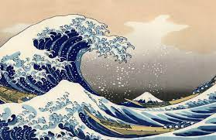 | Ken Done  Collaborative Art  Using wax resist and a wash  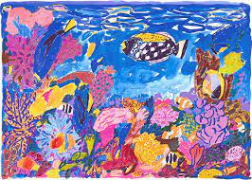 |  |  | Nature’s Paintbrushes  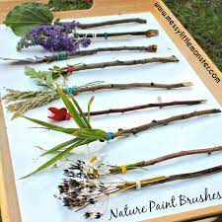 |  | Nature’s dyes  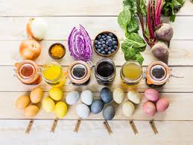
RE |  |  |  |  |  |  |  |  | Palm Sunday
RSHE  Relationships | Are all families the same? | How do I know if I’m a good friend? | How do I greet people I know? | Who in school can I go to for help? |  | How can I be my own best friend? |  | What makes someone special to me?

